**Lab 6**

**To Demonstrate the Working of Binary Subtractor**

***Note: You may draw all the logic diagrams with hand and paste the pictures here or on logicly software with your name, roll number & section mentioned in your workspace. Make sure that all of your connections are clearly visible and distinguishable.***

**Tasks**

1. **Construct a logic circuit for half and full subtractor with the help of truth table/Boolean expression. Also write the Boolean expression for output(s).**

Half Subtractor

1. Truth Table

|  |  |  |  |
| --- | --- | --- | --- |
| A | B | Difference | Borrow |
| 0 | 0 | 0 | 0 |
| 0 | 1 | 1 | 1 |
| 1 | 0 | 1 | 0 |
| 1 | 1 | 0 | 0 |

1. Boolean Expression (Simplified)

Difference:

D = A X-OR B = A⊕B

Borrow:

B = NOT A AND B = A’.B

1. Logic Diagram

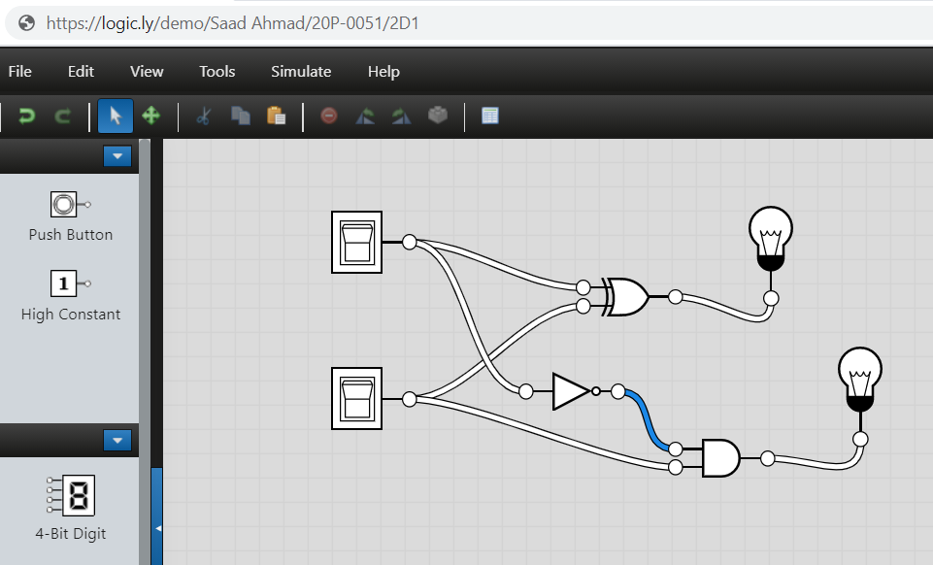

1. Software Simulation (Show here your results for each combination that gives a high output)

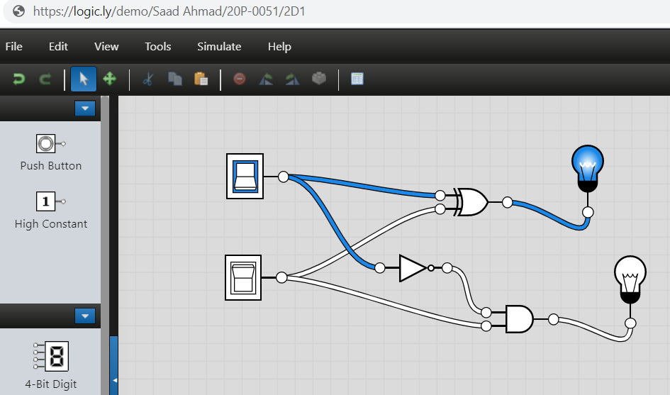

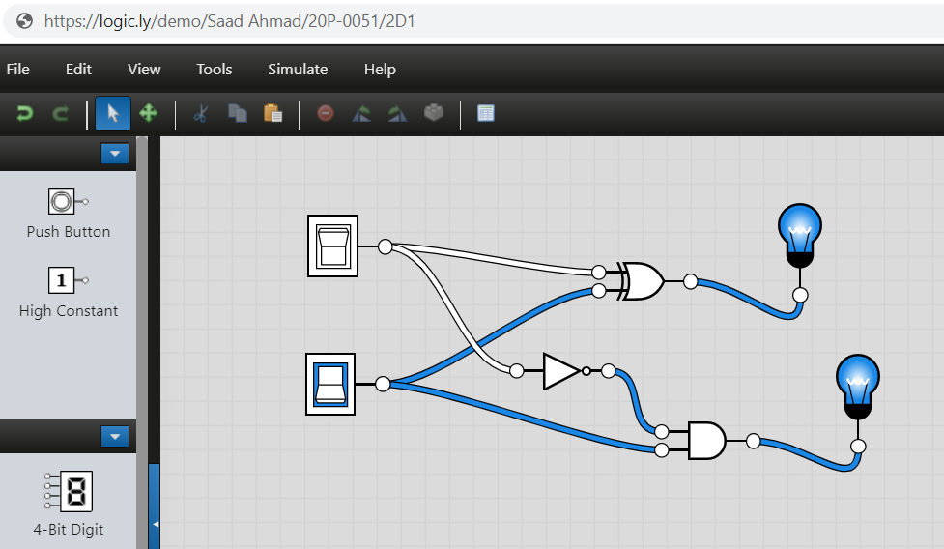

Full Subtractor

1. Truth Table

|  |  |  |  |  |
| --- | --- | --- | --- | --- |
| A | B | Borrow in | Difference | Borrow out |
| 0 | 0 | 0 | 0 | 0 |
| 1 | 0 | 0 | 1 | 0 |
| 0 | 1 | 0 | 1 | 1 |
| 1 | 1 | 0 | 0 | 0 |
| 0 | 0 | 1 | 1 | 1 |
| 1 | 0 | 1 | 0 | 0 |
| 0 | 1 | 1 | 0 | 1 |
| 1 | 1 | 1 | 1 | 1 |

1. Boolean Expression (Simplified)

Difference:

D = (A X-OR B) XOR BIN = (A ⊕ B) ⊕ BIN

Borrow:

BOUT = (NOT A AND B) OR {NOT (A X-OR B)} BIN=A’.B +{(A ⊕ B)}’BIN

1. Logic Diagram

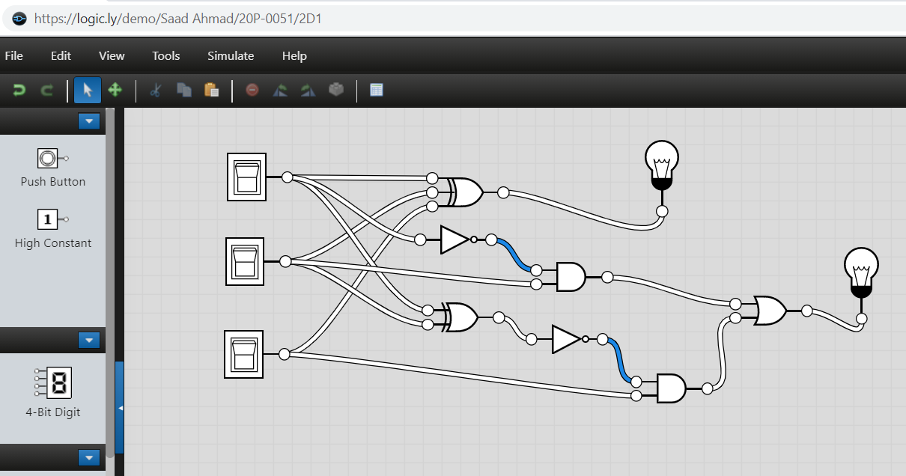

1. Software Simulation (Show here your results for each combination that gives a high output)

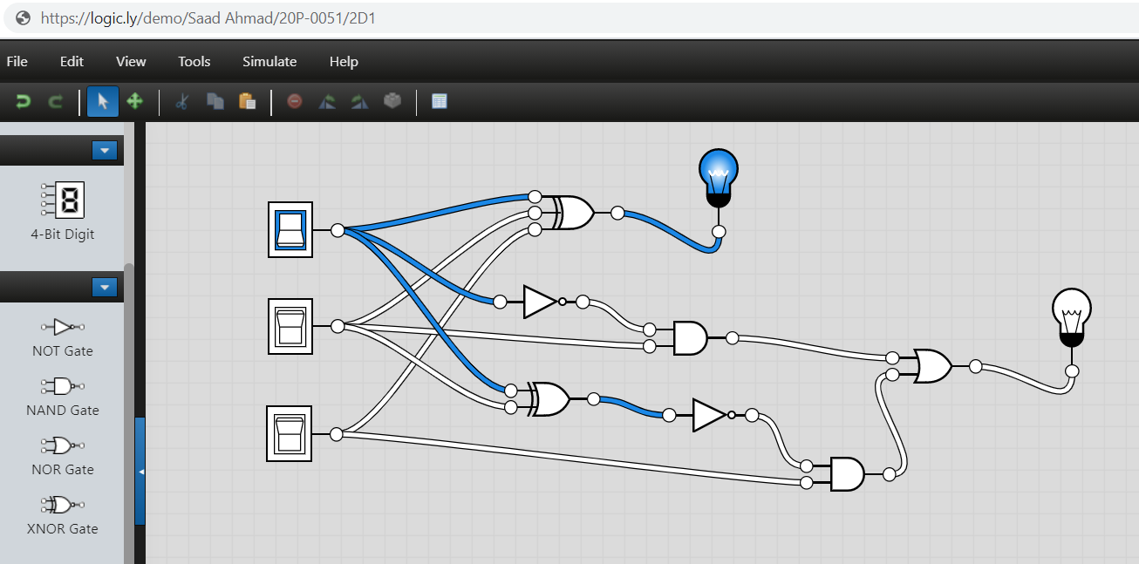

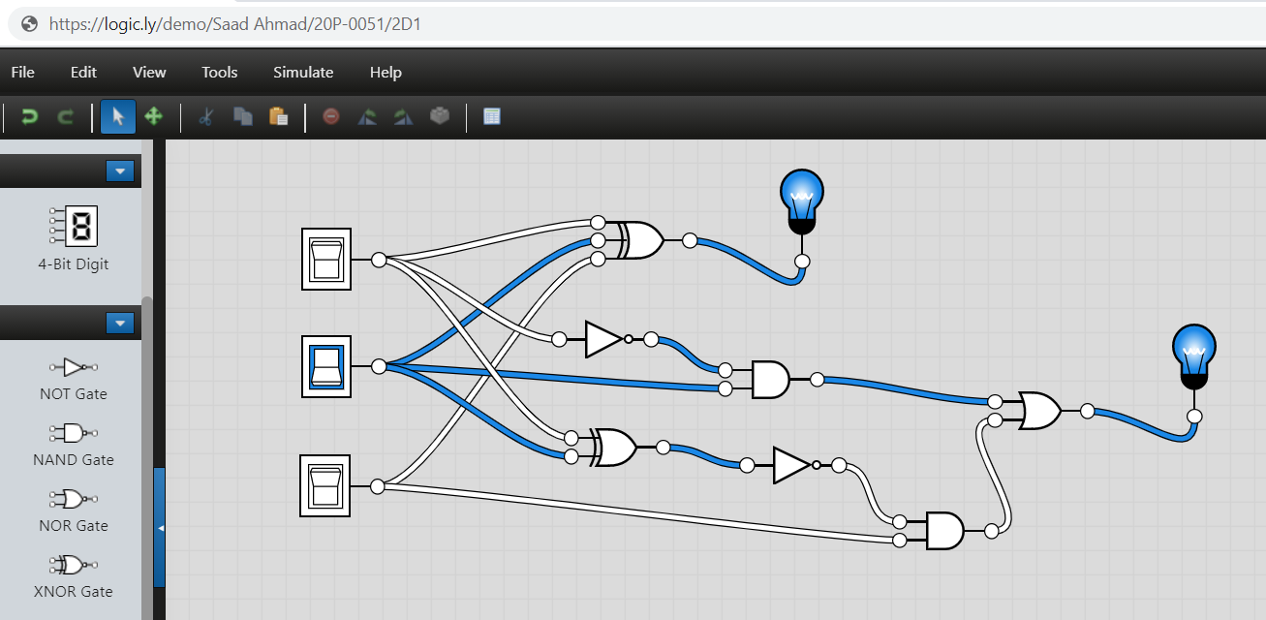

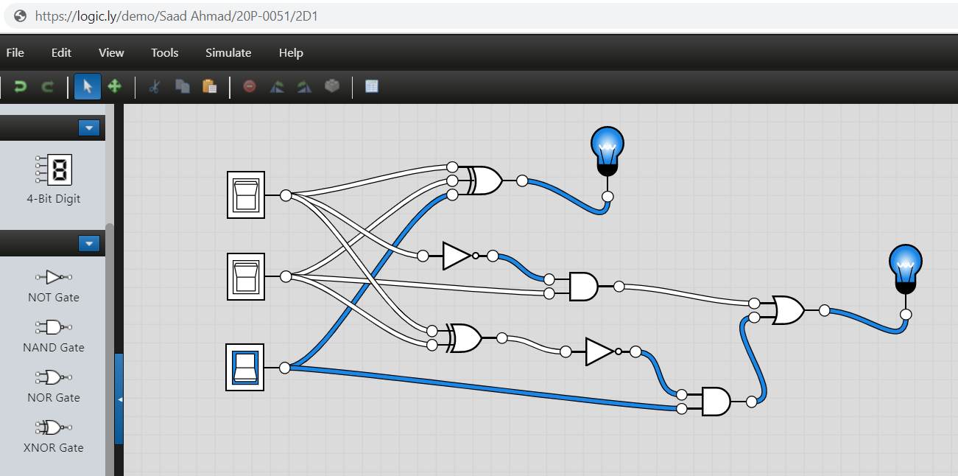

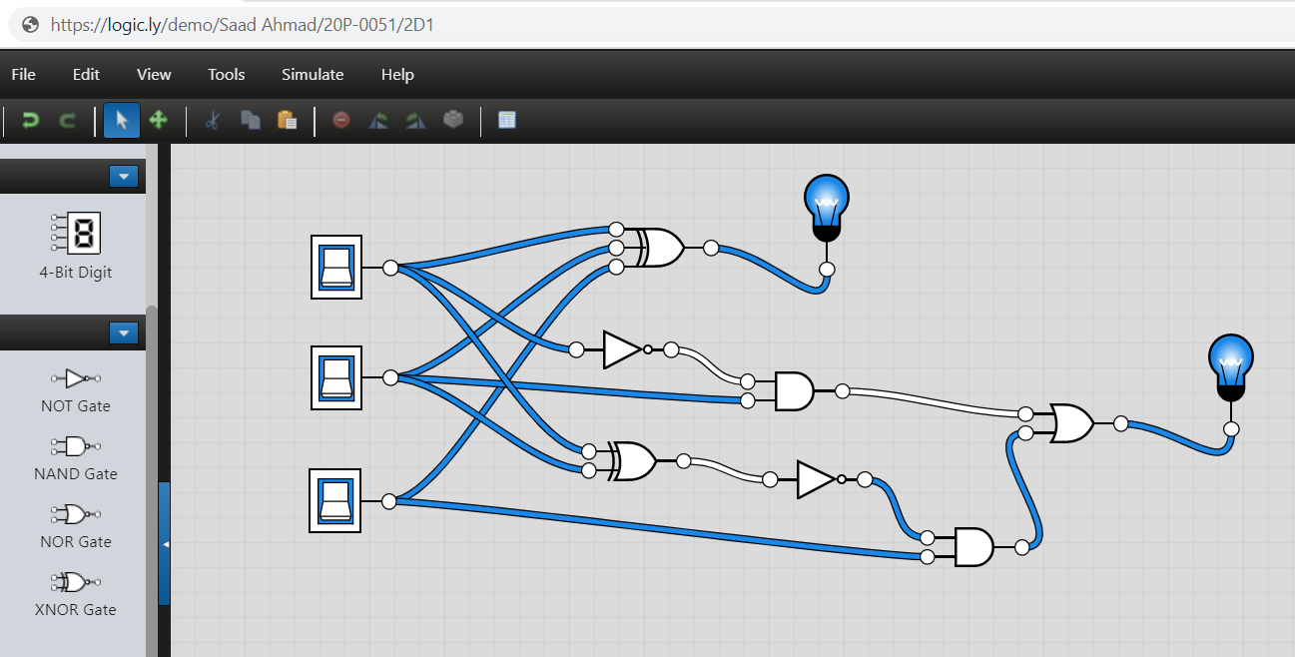

1. **A full subtractor can be implemented using 2-half subtractors. Demonstrate the logic diagram for the said circuit. Simulate your circuit for the verification of results.**
2. Logic Diagram of Full Subtractor using 2-Half Subtractor

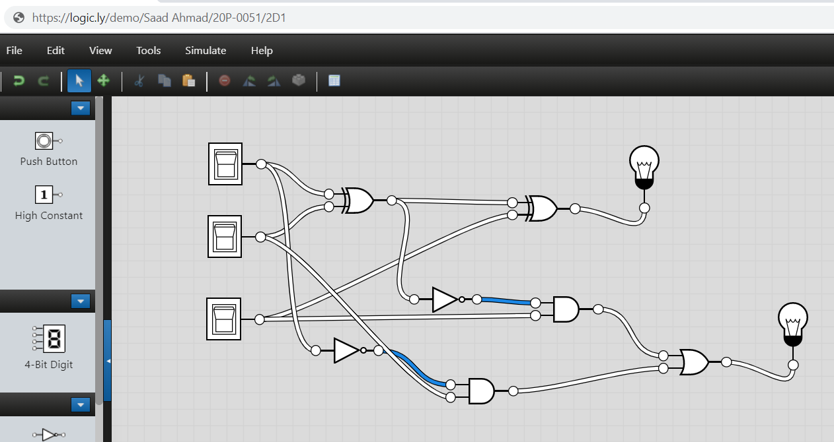

1. Software Simulation (Show here your results for each combination that gives a high output)

